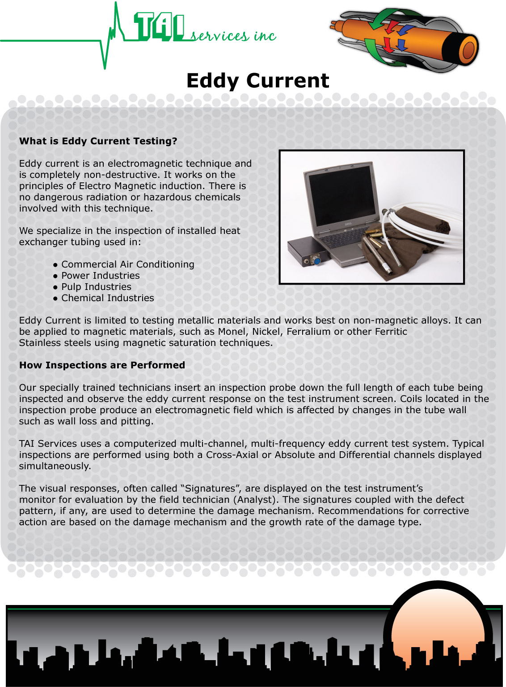
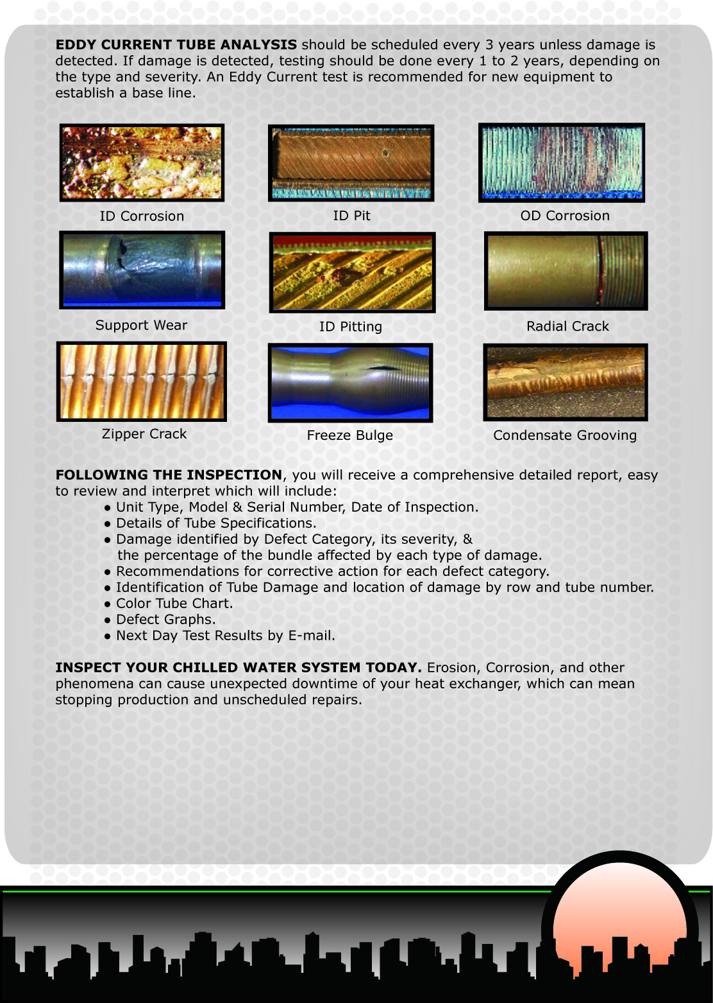
Address 1  Address 2  City, ST, Zip | Phone:  Fax:  Email:  Web site

